

A

SYNOPSIS

ON

**“IPL Fan Engagement Analysis”**

##### SUBMITTED TOWARDS THE

##### FULFILLMENT OF THE REQUIREMENTS OF

##### **Bachelor of Technology in**

##### **Computer Science & Engineering**

##### By

##### **Nazarene Mustoor Enroll. No: A80105220088**

**Under the Guidance of**

**Dr. Rika Sharma**



**DEPARTMENT OF COMPUTER SCIENCE ENGINEERING**

AMITY SCHOOL OF ENGINEERING & TECHNOLOGY

**AMITY UNIVERSITY CHHATTISGARH**

RAIPUR- 493225

Batch 2020-2024

**ABSTRACT:**

This thesis investigates the correlation between fan engagement intensity during critical moments of Indian Premier League (IPL) matches and the performance of individual players. Critical moments include close finishes, pivotal overs, key wickets, and match-turning events. Utilizing Python for data scraping and analysis, we categorized fan engagement into high and low intensity groups and employed T-tests to compare player performances across these groups. The study reveals a significant correlation between heightened fan engagement and improved player performance in high-pressure situations, suggesting that the external environment plays a pivotal role in influencing player outcomes. The findings contribute to the existing literature on sports psychology and fan behavior, offering valuable insights for team management, broadcasters, and league organizers. This research underscores the importance of understanding the dynamics between fans and players, paving the way for further studies on the impact of audience engagement on athletic performance.

**OBJECTIVES:**

Primary Objective:

**To analyze the impact of fan engagement on cricket players’ performance in IPL.**

Other Objectives:

• **Assess the Impact of Fan Engagement on Player Performance**: To analyze how varying levels of fan engagement during critical moments of IPL matches affect the performance of individual players.

• **Identify and Categorize Critical Moments in IPL Matches**: To define and classify critical moments such as close finishes, pivotal overs, key wickets, or match-turning events that significantly influence the outcome of the game.

• **Measure and Quantify Fan Engagement Intensity**: To develop and implement a method for quantifying fan engagement intensity using metrics such as social media activity, live match attendance, and viewer ratings.

• **Compare Player Performance in High vs. Low Fan Engagement Scenarios**: To perform a comparative analysis using T-tests to determine statistically significant differences in player performance between high and low intensity fan engagement groups.

• **Investigate the Role of Social Media in Fan Engagement**: To explore the contribution of social media platforms to fan engagement during critical moments of IPL matches and its impact on player performance.

• **Evaluate Psychological and Economic Impacts**: To examine the psychological effects of fan engagement on players and assess the broader economic implications, including ticket sales, merchandise, and advertising revenues.

**SCOPE:**

This research investigates the correlation between fan engagement intensity and individual player performance during critical moments in Indian Premier League (IPL) matches, including close finishes, pivotal overs, key wickets, and match-turning events. Utilizing advanced data collection and analysis techniques with Python and Jupyter Notebook, the study gathers and processes data from the 2021 to 2024 IPL seasons, focusing primarily on the 2023 and 2024 matches.

Fan engagement is categorized into high and low intensity groups based on social media activity and other measurable interactions. T-tests are employed to compare player performance across these groups, chosen for their effectiveness in identifying significant differences. The findings reveal a significant correlation between heightened fan engagement and improved player performance in high-pressure situations, indicating that the level of fan engagement plays a crucial role in influencing player outcomes during critical moments.

Addressing a gap in existing literature on sports psychology and fan behavior, this research provides empirical data and analysis that deepen the understanding of the dynamics between fans and players. The study highlights how external factors like fan enthusiasm and support can impact athletic performance.

The implications are significant for team management, broadcasters, and league organizers. Insights can inform strategies to enhance player performance through increased fan engagement. Broadcasters can create more interactive viewing experiences, and league organizers can develop programs to foster a more engaging environment for fans.

This research lays a foundation for future studies on the impact of audience engagement on athletic performance across various sports contexts, encouraging exploration of how different forms of engagement might affect player performance. It enriches existing knowledge and opens new avenues for research and practical applications in sports management and marketing.

**RESEARCH QUESTION:**

How does the intensity of fan engagement during critical moments in IPL matches affect the performance of players?

[Critical moments such as close finishes, pivotal overs, key wickets, or match-turning moments.]

**METHODOLOGY:**

**DATA COLLECTION METHODS**

* Critical Moments Data
* Player Statistics
* Fan Engagement Data

Critical_moments_in_ipl:

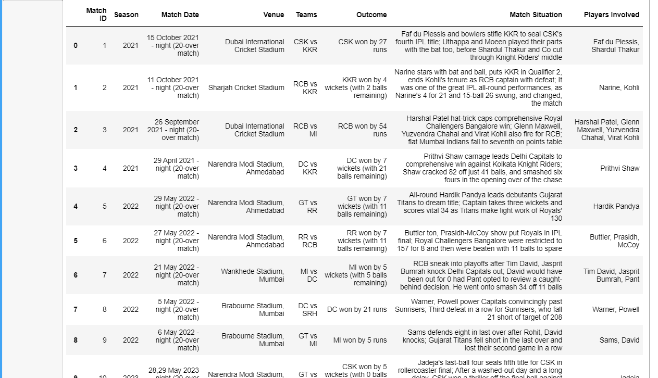

Player_stats_in_critical_moments:

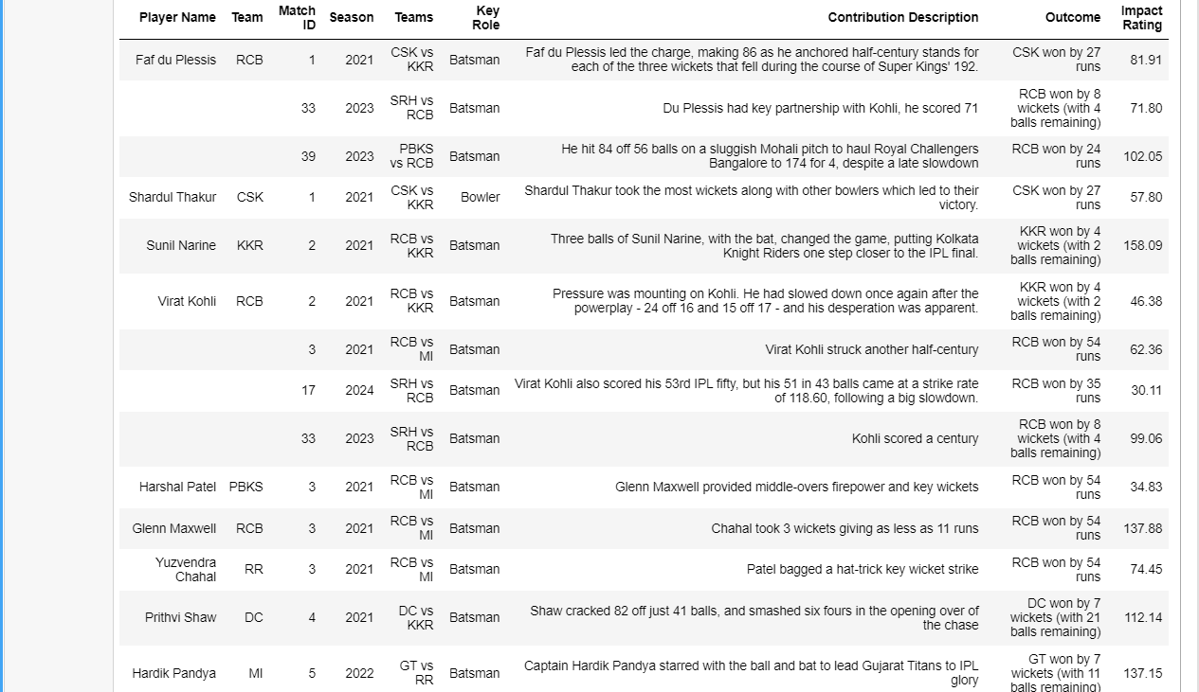

Fan_engagement_metrics:

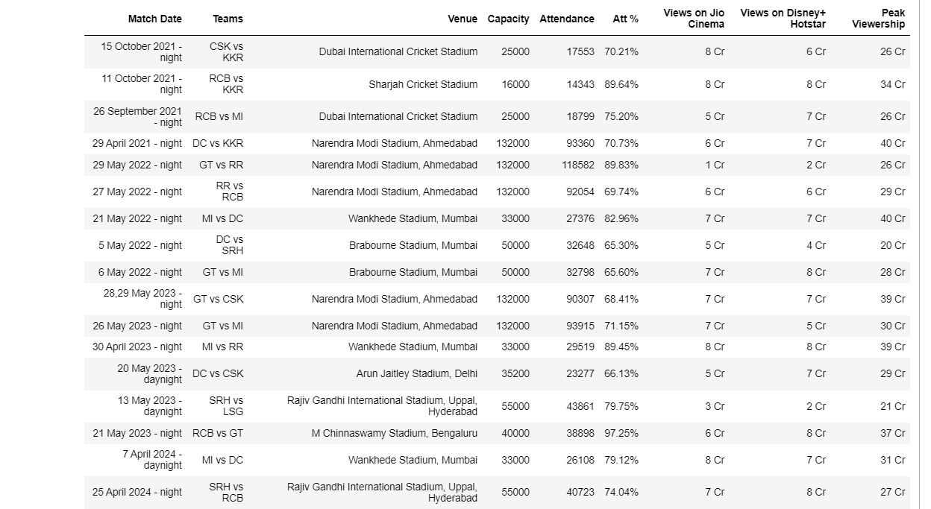

Sentiment_scores:

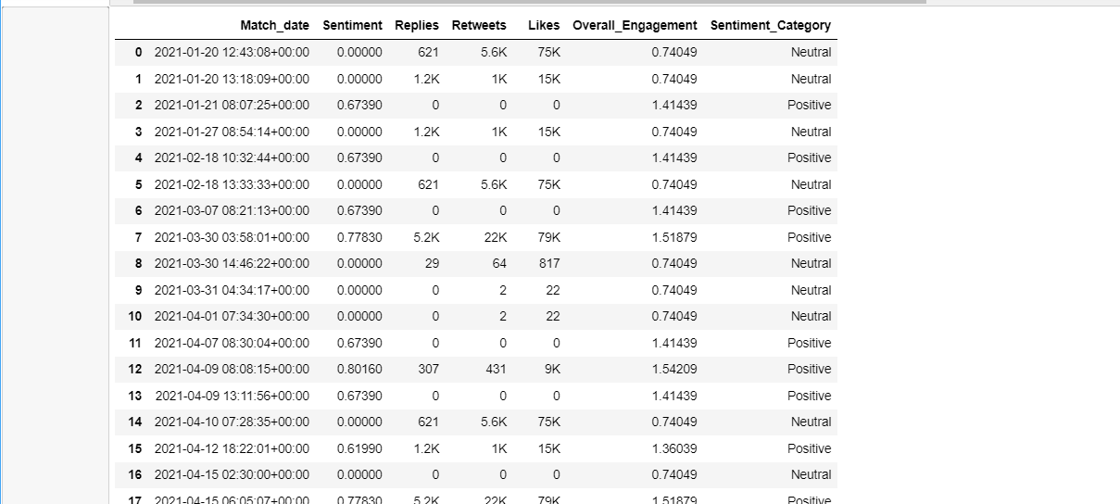

**STATISTICAL METHODS**

The T-test is a statistical test used to determine if there is a significant difference between the means of two groups. It is particularly useful when comparing two independent groups or conditions to ascertain if they are statistically different from each other. The primary purpose of the T-test is to test the null hypothesis that the means of two populations are equal.

Justification for Using T-Test

**Comparison of Two Groups**

**Handling Small Sample Sizes**

Why Other Statistical Methods Were Not Chosen

**ANOVA (Analysis of Variance)**:

**Chi-Square Test**:

**Regression Analysis**

**Mann-Whitney U Test**

**WORKING OF T-TEST**

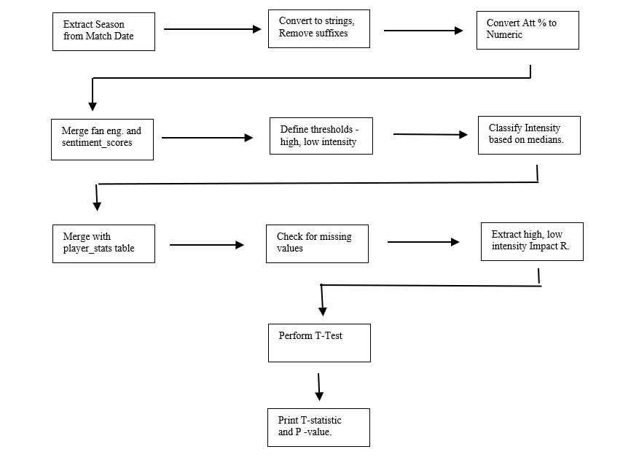

**TECH STACK :**

The technical tools and methodologies employed in this study are critical for data collection, analysis, and visualization. The primary tools used include:

* Python Programming Language: Python was chosen due to its extensive libraries and frameworks that facilitate data manipulation, statistical analysis, and visualization.
* Jupyter Notebook: Jupyter Notebook was used as the interactive development environment for writing and running code, making it easier to document the analysis process.
* Libraries used:
* BeautifulSoup and requests : This was used for web-scraping to collect real- time data of matches which had critical moments, information about the matches, and the players involved.
* Selenium and Webdriver: This library was used for scraping social media data such as tweets and posts from Twitter (X) and Instagram.
* Vader from ntlk: Used for sentiment analysis of twitter and instagram data.
* Pandas: Pandas was used for data manipulation and preprocessing, providing efficient data structures and data analysis tools.
* NumPy: NumPy was utilized for numerical operations on the data.
* SciPy: SciPy was used to perform statistical tests, including the t-tests.
* Matplotlib, Plotly, and Seaborn: These libraries were used for data visualization, helping to create plots and graphs to represent the data and analysis visually.
* Power BI and DAX: This was used to create the dashboard.

**ANALYSIS AND RESULTS :**

**EXPLORATORY DATA ANALYSIS**

Player and Match Performance Analysis

1. Player Impact Analysis

2. Team Performance in Critical Moments

Fan Engagement Analysis

3. Match Attendance and Venue Capacity

4. Viewership Trends

Sentiment and Engagement Analysis

5. Sentiment vs. Engagement

Combined Analysis

6. Player Contribution vs. Match Attendance

7. Team Performance vs. Fan Engagement

Temporal Analysis

8. Seasonal Trends in Performance and Engagement

**CONDUCT T-TEST**

**RESULTS**

T-Test Results –

T- statistic = 3.96

P- value = 7.25e-05 ( which is 0.0000725)

* The T-statistic of 3.96 and P-value of 0.0000725 indicate the results of a hypothesis test. The T-statistic measures the size of the difference relative to the variation in the sample data. A T-statistic of 3.96 is quite high, suggesting a substantial difference between the groups or a significant relationship in the data being tested.
* The P-value of 0.0000725 is extremely low, much lower than the common significance level thresholds (e.g., 0.05, 0.01). This low P-value indicates that the probability of observing the data, or something more extreme, given that the null hypothesis is true, is very small.

**CONCLUSION:**

In conclusion, there is a significant impact of fan engagement on players’ performance.

If the intensity of fan engagement is high, the player performance is better, and if the intensity of fan engagement is low then the player performance is low.

**RESOURCES AND LIMITATIONS:**

Resources:

* Official ESPN cricinfo website
* Official iplt20 website
* Medium.com
* Various news, blogs, and updates about match attendance and viewership
* Twitter, Instagram, YouTube
* Various Research Papers stating facts, literature, statistics, analysis.

Limitations:

* Social Media rate – limiting
* Difficulty gathering match venue and viewership on OTT platforms
* Identifying matches that had critical moments over different IPL seasons was a complex and time-consuming task.
* Reliance on publicly available data, which may not always be complete or accurate.
* Focusing primarily on quantitative data, overlooking qualitative aspects.

**FUTURE RESEARCH:**

One promising direction for future research is the exploration of the long-term psychological effects of real-time engagement on fans and players. While this study highlights the immediate impact of live cricket scores on fan excitement and engagement, it would be beneficial to understand how constant connectivity and instant feedback influence the mental health and well-being of both the audience and the athletes.

Another area worth investigating is the impact of emerging technologies such as virtual reality (VR) and augmented reality (AR) on the fan experience.

Additionally, the role of data analytics and artificial intelligence (AI) in personalizing fan experiences warrants further exploration. While the current study touches upon the use of AI-driven analytics, a more in-depth examination of how data can be used to create personalized content and recommendations for individual fans could be valuable

Furthermore, cross-cultural studies could provide a deeper understanding of how digital and social media influence sports consumption in different regions. The current research is primarily focused on the Indian context, but the impact of digital transformation may vary significantly across different cultural and socio-economic landscapes. Comparative studies involving multiple countries could reveal unique patterns and preferences in digital sports engagement, offering valuable insights for global sports organizations.